**SECTION 1**

1)

**Relation:** shows the relationship of data stored in a format of tables, consists of rows and columns

(e.g. Tables EMP and DEPT in appendix 1 are both relations)

**Attribute:** a single field or columns in a relation/table

(e.g. DEPT has an attribute named DEPTNO)

**Domain:** the set of allowed values for each attribute

(e.g. DEPTNO in the table DEPT, has a domain of an integer)

**Tuple:** a single record or row of a relation/table

(e.g. EMP has a record containing:

EMPNO:7369, ENAME: SMITH, JOB: CLERK, MGR: 7902, HIREDATE: 1980-12-17, SAL: 800,

COMM: , DEPTNO: 20)

**Degree:** the number of attributes or columns that exists in the relation

(e.g. EMP has degree 8, DEPT has degree 3)

**Cardinality:** the number of tuples or rows that exists in the relation

(e.g. EMP has a cardinality of 14, DEPT has 4)

2)

**Candidate Key:** a minimal super key that cannot uniquely represent tuples in our tables with fewer attributes

(e.g. the EMPNO attribute in the table EMP and DEPTNO attribute in the table DEPT)

**Primary Key:** a candidate key chosen as the fundamental key to uniquely represent data in a relation

(e.g. the EMPNO candidate key and DEPTNO candidate key)

**Foreign Key:** another table’s primary key

(e.g. EMP has a foreign key attribute named DEPTNO, which is a primary key for DEPT)

**SECTION 2**

3)

create database w19yang_DDL;

create table CATEGORY

(

CatCode varchar(2),

CatDesc varchar(10)

);

4)

create table EMPLOYEES

(

Emp_num int(5),

Lastname varchar(15),

Firstname varchar(15),

Job_class varchar(4)

);

5)

alter table EMPLOYEES

add EmpDate date,

add EndDate date;

6)

alter table EMPLOYEES

modify Job_class varchar(2);

7)

alter table EMPLOYEES

drop EndDate;

8)

rename table EMPLOYEES to JL_EMPS;

**SECTION 3**

9)

create database w19yang_1;

create table EMP

(

EMPNO int(4) primary key,

ENAME varchar(8),

JOB varchar(9),

MGR varchar(4),

HIREDATE date,

SAL varchar(4),

COMM varchar(4),

DEPTNO int(2)

);

create table DEPT

(

DEPTNO int(2) primary key,

DNAME varchar(10),

LOC varchar(15)

);

10)

insert into EMP

(EMPNO, ENAME, JOB, MGR, HIREDATE, SAL, COMM, DEPTNO)

values

(7369, 'SMITH', 'CLERK', '7902', '1980-12-17', '800', '', 20),

(7499, 'ALLEN', 'SALESMAN', '7698', '1981-02-20', '1600', '300', 30),

(7521, 'WARD', 'SALESMAN', '7698', '1981-02-22', '1250', '500', 30),

(7566, 'JONES', 'MANAGER', '7839', '1981-04-02', '2975', '', 20),

(7654, 'MARTIN', 'SALESMAN', '7698', '1981-09-28','1250', '1400', 30),

(7698, 'BLAKE', 'MANAGER', '7839', '1981-05-01', '2850', '', 30),

(7782, 'CLARK', 'MANAGER', '7839', '1981-06-09', '2450', '', 10),

(7788, 'SCOTT', 'ANALYST', '7566', '1982-12-09', '3000', '', 20),

(7839, 'KING', 'PRESIDENT', '', '1981-11-17', '5000', '', 10),

(7844, 'TURNER', 'SALESMAN', '7698', '1981-09-08', '1500', '0', 30),

(7876, 'ADAMS', 'CLERK', '7788', '1983-01-12', '1100', '', 20),

(7900, 'JAMES', 'CLERK', '7698', '1981-12-03', '950', '', 30),

(7902, 'FORD', 'ANALYST', '7566', '1981-12-03', '3000', '', 20),

(7934, 'MILLER', 'CLERK', '7782', '1982-01-23', '1300', '', 10);

insert into DEPT

(DEPTNO, DNAME, LOC)

values

(10, 'ACCOUNTING', 'NEW YORK'),

(20, 'RESEARCH', 'DALLAS'),

(30, 'SALES', 'CHICAGO'),

(40, 'OPERATIONS', 'BOSTON');

**SECTION 4**

create database w19yang_2;

create database w19yang_3;

create database w19yang_4;

create database w19yang_5;

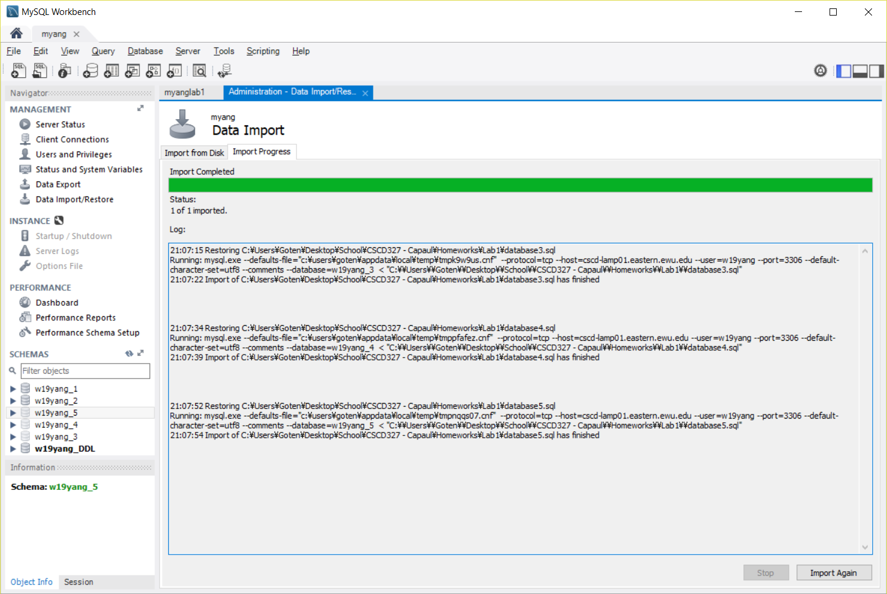

Not really sure how to show that I did this, but here’s a screenshot of my import log. I went to Server -> Data Import -> Pick import file and chose the correct database -> Import.